**1. Project Overview**

* **Objective**: Develop a user-friendly platform that allows property owners to list their rental properties and tenants to search, book, and manage rental homes.
* **Features**:
  + **For Property Owners**: List properties, set prices, manage bookings, and communicate with potential tenants.
  + **For Tenants**: Search properties, view property details, book rentals, make payments, and submit reviews.

**2. Tech Stack**

* **MongoDB**: For database storage, handling property listings, user details, bookings, and payments.
* **Express.js**: Backend framework to manage API endpoints and business logic.
* **React**: Frontend framework for developing a dynamic user interface and enhancing user experience.
* **Node.js**: Backend runtime environment for handling server-side logic.

**3. App Architecture and Structure**

**Backend (Node.js, Express)**

* **Database Models (MongoDB)**:
  + **User**: Store user information, type (Owner/Tenant), authentication, and account details.
  + **Property**: Hold property details like title, location, price, amenities, and availability.
  + **Booking**: Track bookings with property ID, user ID, booking status, and dates.
  + **Payment**: Record payment transactions, payment status, amount, and booking reference.
  + **Reviews**: Store tenant feedback and ratings on properties.
* **API Endpoints**:
  + **Auth**: /api/auth/register, /api/auth/login, and /api/auth/logout.
  + **Properties**:
    - **Create/Update/Delete Listings**: /api/properties for CRUD operations by owners.
    - **View Property Listings**: /api/properties for tenants to view listings.
  + **Booking**:
    - **Create Booking**: /api/bookings for booking a property.
    - **Manage Bookings**: /api/bookings/:id for managing or canceling bookings.
  + **Payment Processing**: /api/payments for handling and verifying payments.
  + **Reviews**: /api/reviews for posting and fetching reviews.
* **Authentication and Authorization**:
  + **JWT Tokens**: Issue JWT tokens upon login to authenticate users for secure API access.
  + **Role-Based Access Control**: Ensure only property owners can create/update listings and tenants can book.
* **Third-Party Integrations**:
  + **Payment Gateways**: Integrate with Stripe or PayPal API for secure and verified transactions.
  + **Geolocation API**: For properties, integrate a mapping or geolocation API (like Google Maps API) for location-based search.

**Frontend (React)**

* **Components and Pages**:
  + **Home Page**: Display featured properties, search functionality, and filters for city, price range, and property type.
  + **Property Listing Page**: List properties with images, price, location, and brief details.
  + **Property Detail Page**: Show property images, description, amenities, reviews, and booking options.
  + **User Profile**:
    - **For Tenants**: View and manage bookings, leave reviews, and track payment history.
    - **For Owners**: Add/edit properties, view bookings, and respond to messages.
  + **Booking and Payment Flow**: Guide tenants through the booking process and secure payment.
  + **Login/Register Page**: Authentication flow with separate options for tenants and property owners.
* **State Management**:
  + Use **React Context API** or **Redux** for managing global state, such as user authentication and booking data across components.
* **Frontend Styling**:
  + **UI Framework**: Use Material-UI or Bootstrap for responsive and modern design elements.
  + **Animations**: Add animations with libraries like Framer Motion to improve user experience.

**Key Functionalities**

* **Property Search with Filters**: Filter by price, location, property type, and amenities. Enhance with a live search or autocomplete feature.
* **Booking Management**: Tenants can book available properties, and owners can view/manage bookings.
* **Payment Processing**: Ensure secure transactions and offer a receipt/confirmation on successful payment.
* **Review and Rating System**: Allow tenants to review properties, helping future users make informed decisions.
* **Responsive Design**: Ensure the app is mobile-friendly, so users can browse and book properties on any device.

**4. Implementation Steps**

**Backend Development**

1. **Setup Express Server**: Configure basic server setup with routes for properties, bookings, and users.
2. **Database Configuration**: Use MongoDB Atlas (cloud-based) or local MongoDB, with mongoose schemas for data models.
3. **Auth Middleware**: Implement JWT authentication and role-based authorization.
4. **Routes and Controllers**: Create controllers for handling CRUD operations on properties, user authentication, booking, and payment processing.
5. **Testing and Validation**: Use Postman for API testing, and add data validation with libraries like Joi or mongoose-validator.

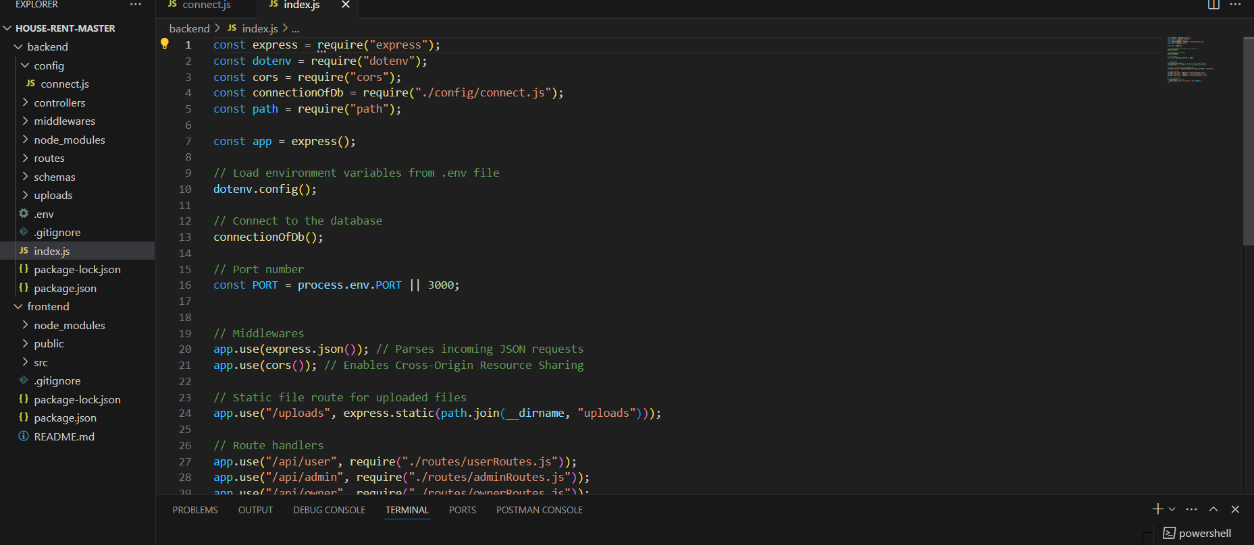

**Frontend Development**

1. **Project Setup**: Initialize React with the necessary dependencies, including React Router, Axios, and Redux (or Context API).
2. **Component Development**: Create components for properties, booking, and user profile pages.
3. **State Management**: Integrate Redux or Context API to manage global state like user data, properties, and bookings.
4. **API Integration**: Use Axios for API calls to fetch and post data, integrating backend endpoints.
5. **Testing**: Test each component for responsiveness and functionality, ensuring error handling and validation.

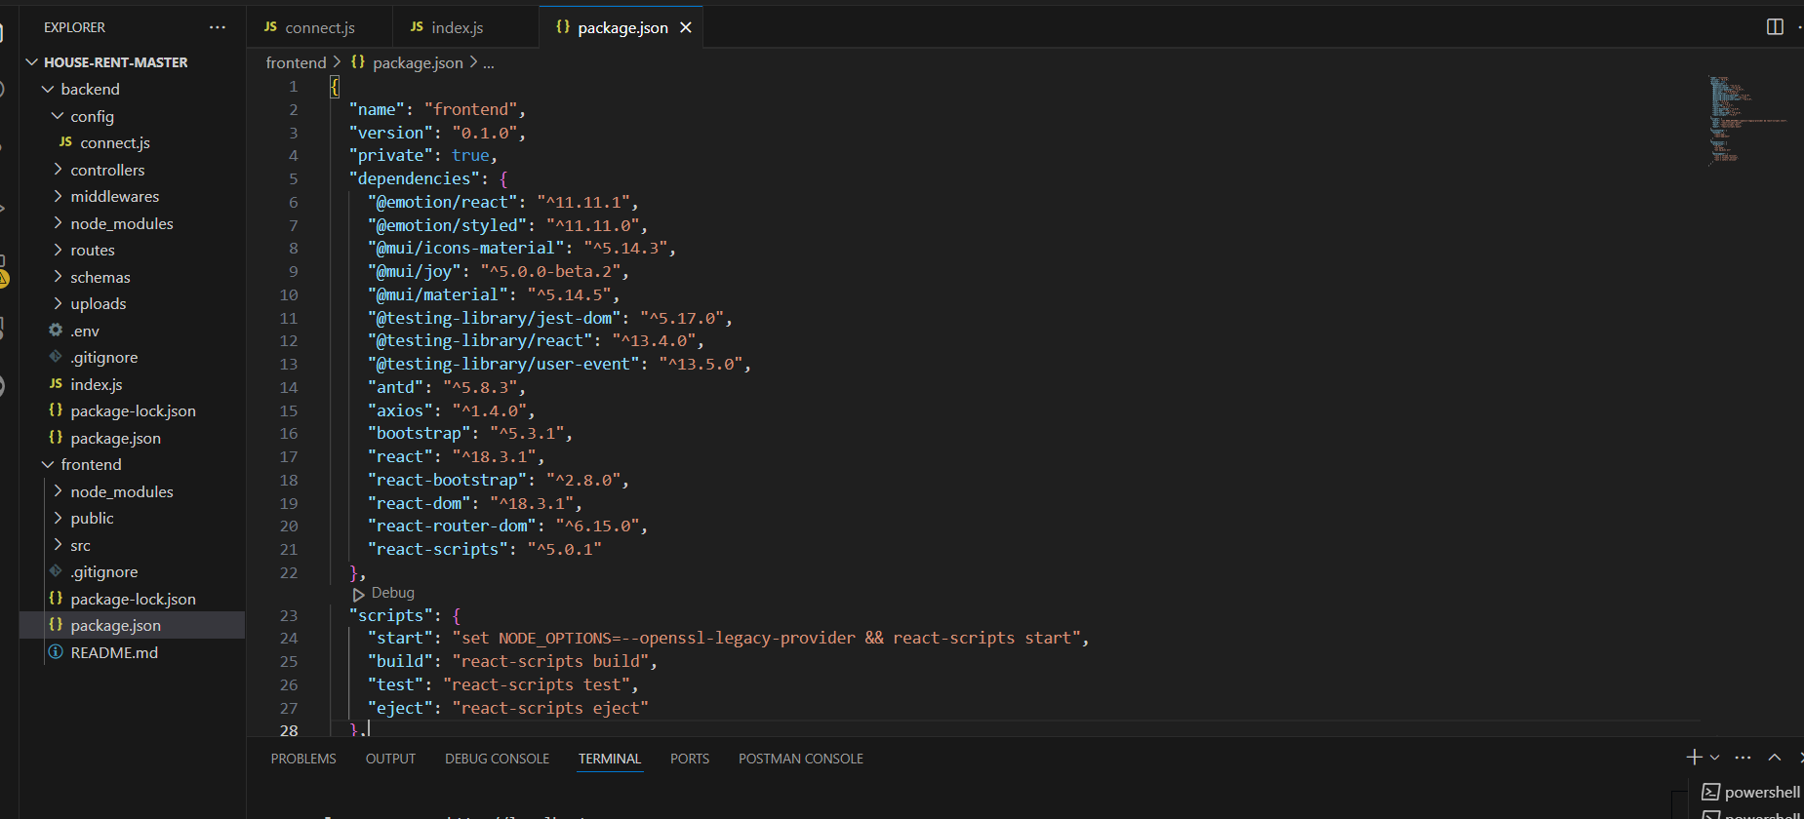

**5. Potential Challenges and Solutions**

* **Scaling**: As user volume grows, optimize backend queries and introduce caching (e.g., Redis) for frequently accessed data like property listings.
* **Security**: Implement strong security practices, including HTTPS, password hashing (bcrypt), input validation, and rate limiting.
* **Performance**: Use lazy loading for images, code-splitting in React, and optimize database indexing for large collections.
* **SEO for Property Listings**: Use server-side rendering (SSR) with a library like Next.js or employ React Helmet to improve the SEO of property listing pages.

**6. Deployment and Hosting**

* **Backend**: Host on a platform like Heroku, DigitalOcean, or AWS with environment variables for sensitive data.
* **Frontend**: Deploy using Netlify or Vercel for smooth frontend hosting.
* **Database**: Use MongoDB Atlas for cloud-based, scalable storage.

**7.Output:** 